Get ready and vote in the 2023 General Election



The Easy Read guide to voting



Developed with input from

People First New Zealand Ngā Tāngata Tuatahi



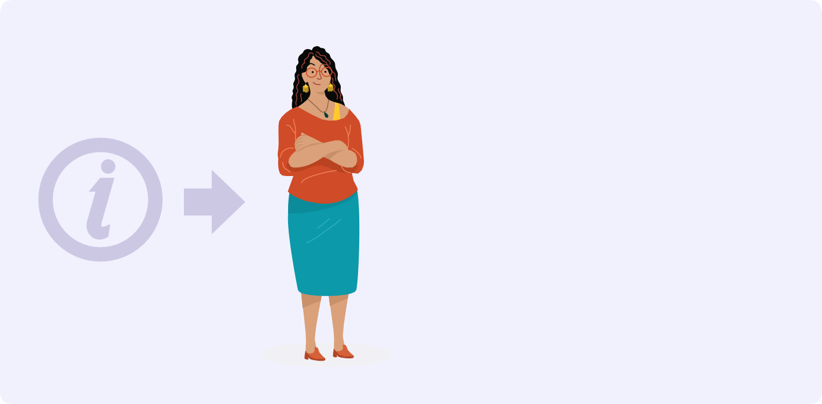

**About this booklet**

This booklet has information about how to:

* enrol to vote
* vote in the 2023 General Election.

**1**



**About the 2023 General Election**

At the **General Election** you can vote for the people and parties who will:

* be in Parliament
* make decisions that affect your life.

**Parliament** is all the people and parties who have been chosen in the election.

Some of the parties in Parliament will form the **Government**.



The **New Zealand Government** decides on things that affect your life like:

* schools
* hospitals
* roads.



**October**

**2023**

**2**

**14**

**October**

**2023**

11 12 1

Voting in the 2023 General Election:

* starts on **Monday 2 October 2023**
* ends at 7pm on election day

which is **Saturday 14 October 2023**.

10

9

8

2

3

4

7 5

6

**2**



**About the 2023 General Election**

In the **General Election** you get

**2 votes** to choose the:

1. **political group** you want to be in Government
2. **person** you want to represent your local area in Parliament.

YOU HAVE 2 VOTES

PARTY vote

electorate vote



A political group is also called a **political party**.



The person who represents your local area in Parliament is

called a **member of Parliament**.

**3**

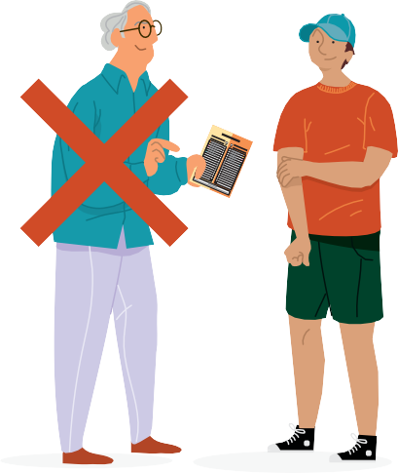

**About choosing who to vote for**

It is your choice who you want to vote for in the General Election.

**Nobody is allowed to tell you who to vote for.**

Here is a list of where you could find more information to help you choose who to vote for:



* newspaper
* television
* radio
* public meetings
* your friends
* your family.

**4**

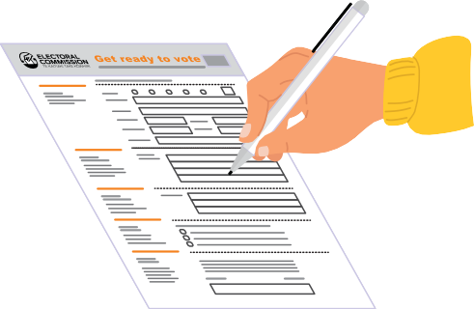

**About getting enrolled to vote**

You have to be enrolled to vote in the General Election.

To get enrolled you have to fill in an enrolment form.

When you enrol your name will go on the **electoral roll**.

***ELECTORAL ROLL***

The **electoral roll** is the list of all the people who have enrolled to vote.

If you are Māori and enrolling for the first time you get to choose if you want to be on the Māori or the general roll.



To get an enrolment form you can:

* call **0800 36 76 56**
* text your name and address to **3676**
* visit **vote.nz**



You can also enrol online at **vote.nz**

To enrol online you will need to use your:

* New Zealand driver licence or
* New Zealand passport or
* RealMe verified identity.

**5**



**About getting enrolled to vote**

The enrolment form will ask for information about you.

It is important to put the right information on the enrolment form.

If you need help to put your information on the enrolment form ask someone to support you.

***ELECTORAL***

***ROLL***

After you have enrolled to vote your name will go on the

electoral roll.



***ELECTORAL***

***ROLL***

If you are worried about your safety if your name goes on the electoral roll you can ask to go on the **Unpublished Roll**.

Your personal details will not be given to anyone.

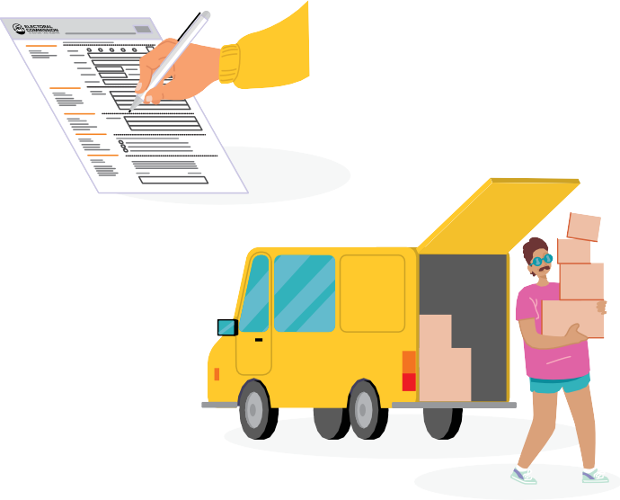

**Get ready to vote**

You must update your information on the electoral roll if you:

* move to a different place
* change your name.

**6**

**Who can get enrolled to vote?**



***ELECTORAL ROLL***

In New Zealand you must **enrol to vote** if you:

* are 18 years or older and
* have lived in New Zealand for more than 1 year at some time in your life

and

* are a New Zealand citizen who is living in New Zealand now or are a permanent resident who is living in New Zealand now.

**Get ready to vote**



VOTE HERE

PōTI I konei

You can enrol to vote any time:

* before election day
* on election day which is

## Saturday 14 October 2023.

You can also enrol at a voting place when you go to vote.

**7**

# About how you can vote

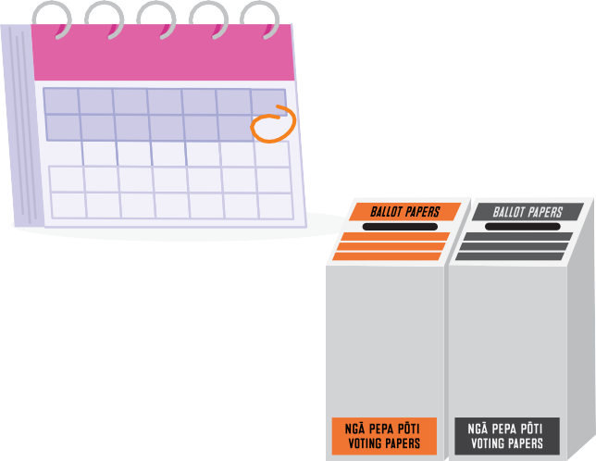

**in the 2023 General Election**

**October 2023**

**14**

**Election day** is the date when the election happens.

You can vote:

* + on election day which is

## Saturday 14 October 2023

* + before election day from

## Monday 2 October 2023.

Voting places are open for about 2 weeks before election day from **Monday 2 October 2023**.

You can vote at any voting place

in New Zealand but it is best to vote close to home.

There will be someone at the voting place to show you what to do.



Do your best to enrol by **Sunday**

**10 September 2023**.

October 2023

2

**EasyVote card**

**2023**

VOTE

HERE

If you enrol by **Sunday 10 September 2023** you will get an information pack in the mail about a week before voting begins.

The information pack has:

* your EasyVote card
* when to vote
* a list of people to choose from.

**8**



**About how you can vote**

**in the 2023 General Election**

When you go to a voting place take your

**EasyVote card** with you.

Give your EasyVote card to the person that works at the voting place.

You can vote without an EasyVote card but it will take longer.

**2020**

**EasyVote card**



The person who works at the voting place will:

* find your name on the electoral roll
* cross your name off the electoral roll
* give your voting paper to you.



If you do not have an EasyVote card you will have to tell the person who works at the voting place your:

* full name
* address.



After you get your voting papers

take them behind the voting screen.

**9**



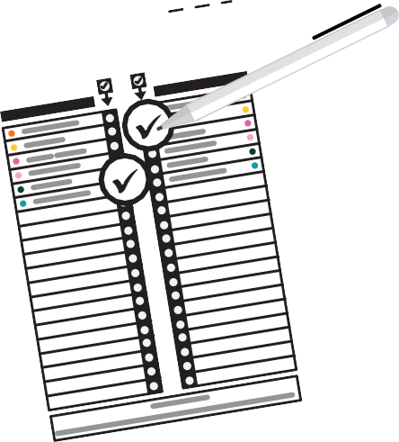

**About how you can vote**

**in the 2023 General Election**

On your voting paper for the General Election put a tick by the name of the:

* **political group** you want to be in Government
* **person** you want to represent your local area in Parliament.

YOU HAVE 2 VOTES

PARTY vote

electorate vote

After you have finished marking your voting papers:

* fold them in half
* put your voting paper for the election in the voting box for your **electorate**.



Your **electorate** is your local area.

If you are voting in a **general electorate** the box will be **orange**.

If you have chosen to vote in a **Māori electorate** the box will be **grey**.

**10**



**1m**



**Voting support**

You can get support to vote from a:

* friend
* person in your family
* person who works at the voting place.



**1m**

A support person is allowed to:

* go with you behind the voting screen
* read out loud the words on the voting paper
* tick the voting paper if you ask them to.



A support person is not allowed to tell you who to

vote for in the General Election.

**11**

# More information about the 2023 General Election



To get more information about how to enrol and vote in the General Election you can:

* visit **vote.nz**
* call **0800 36 76 56**.

**12**



Level 4 34-42 Manners Street

PO Box 3220 Wellington 6140.

E193 – August 2023