•

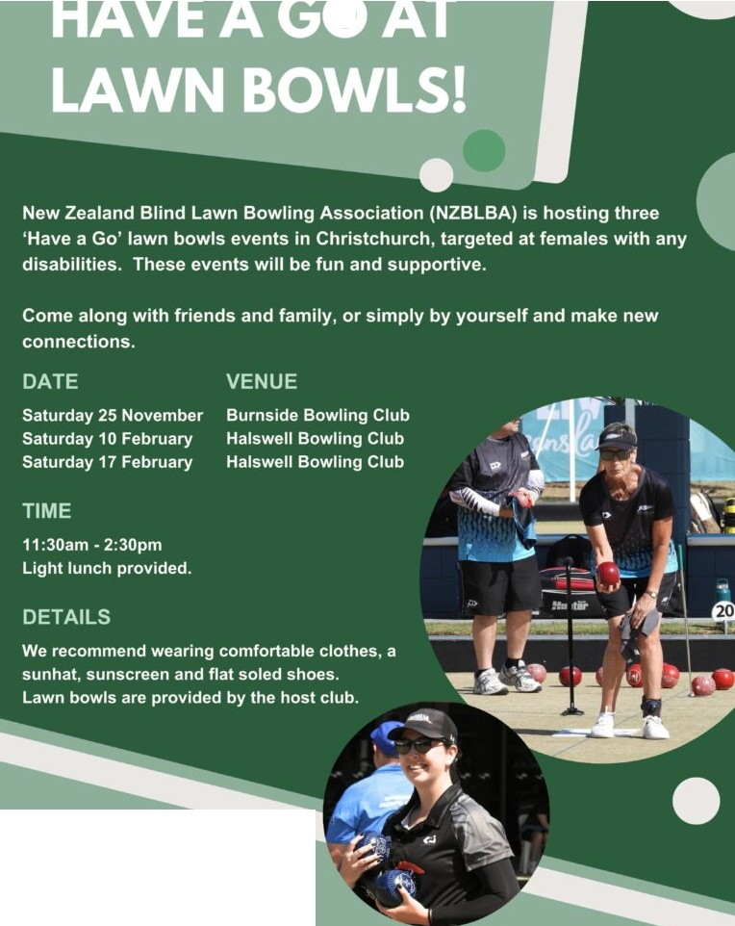

CONTACT

Tayla Bruce [taylabruce22@gmail.com](mailto:taylabruce22@gmail.com)

**+(64)27 66 798** 73