Let's celebrate!

Join us for the CCS Disability Action International Day of Persons with Disabilities celebration.

A fun filled event with music, games & prizes!

**COME ALONG TO** our celebration. Photo booth, face painters and characters for kids, games, food, live music/karaoke and fun prizes!

# Details

**When:** Friday 1 December 2023 11am till 2pm

**Where:** Onuku Taipari Domain Hall 136 Ngamotu Road

New Plymouth

**RSVP:** RSVP or show up on the day, everyone is welcome!

We look forward to seeing you there.

International Day of People with Disabilities (IDPwD) celebrates the achievements and contributions of disabled people to our community. It aims to build awareness, understanding and acceptance.

This event is proudly celebrating:

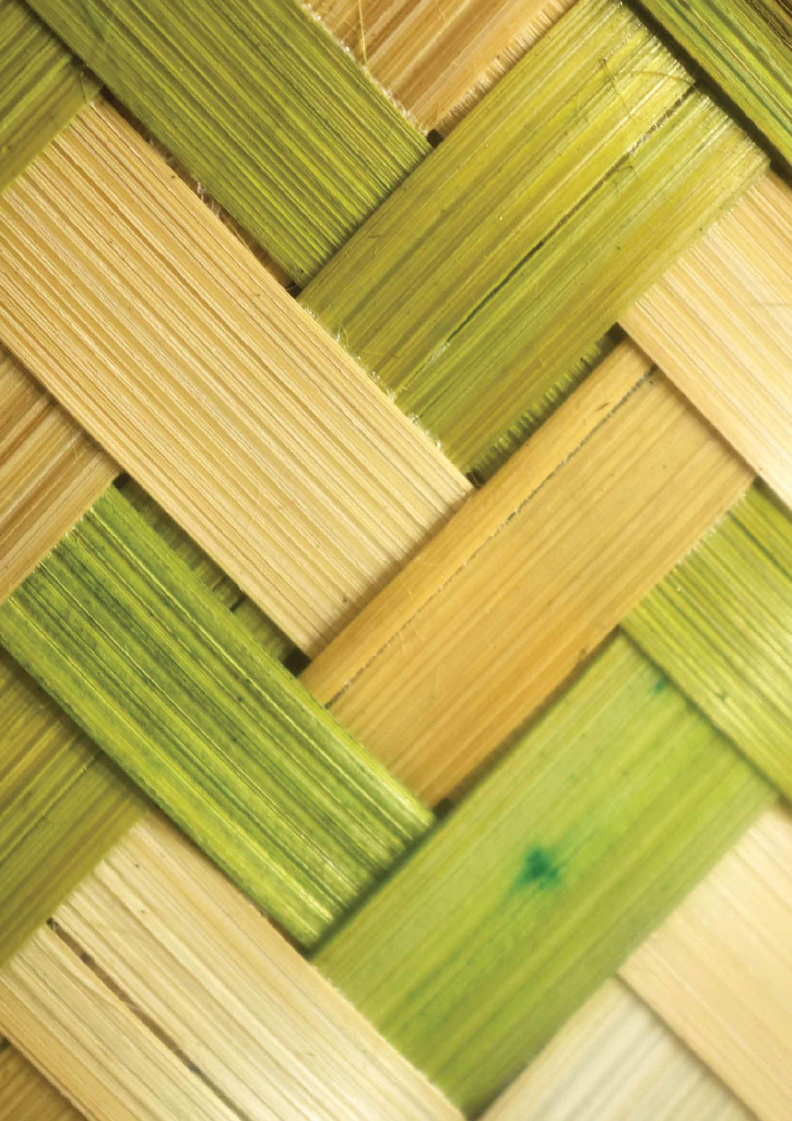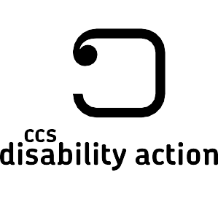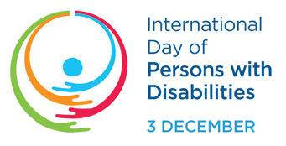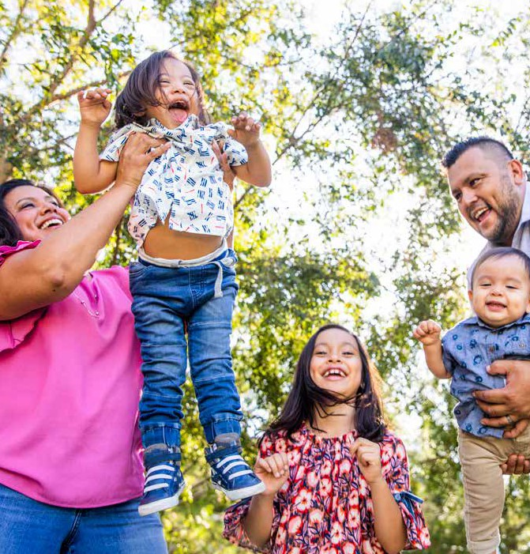

Get in touch Whakapā mai

Please contact Brooke for more information about this event.

**Brooke Jury**

Senior Service Coordinator

06 758 5423 ext 6014 or 027 271 5960

[Brooke.Jury@ccsDisabilityAction.org.nz](mailto:Brooke.Jury@ccsDisabilityAction.org.nz)

[www.facebook.com/ccsDisabilityAction](http://www.facebook.com/ccsDisabilityAction) @ccsdisabilityaction [www.ccsDisabilityAction.org.nz](http://www.ccsDisabilityAction.org.nz/)