Aloha!

It’s Tiki Time

Join us for the CCS Disability Action International Day of Persons with Disabilities celebration.

A fun filled event with music, games & mocktails!

**BREAK OUT YOUR** floral tops and flip flops and come along to our Hawaiian themed celebration. Prizes are up for grabs for the best dressed tropical theme.

# Details

**When:** Friday 1 December 2023 10am till 2pm

**Where:** South and Central Taranaki Hawera Office

85 Princes Street, Hawera

**RSVP:** Please kindly RSVP by

20 November for catering purposes

We look forward to seeing you there.

International Day of People with Disabilities (IDPwD) celebrates the achievements and contributions of disabled people to our community. It aims to build awareness, understanding and acceptance.

This event is proudly celebrating:

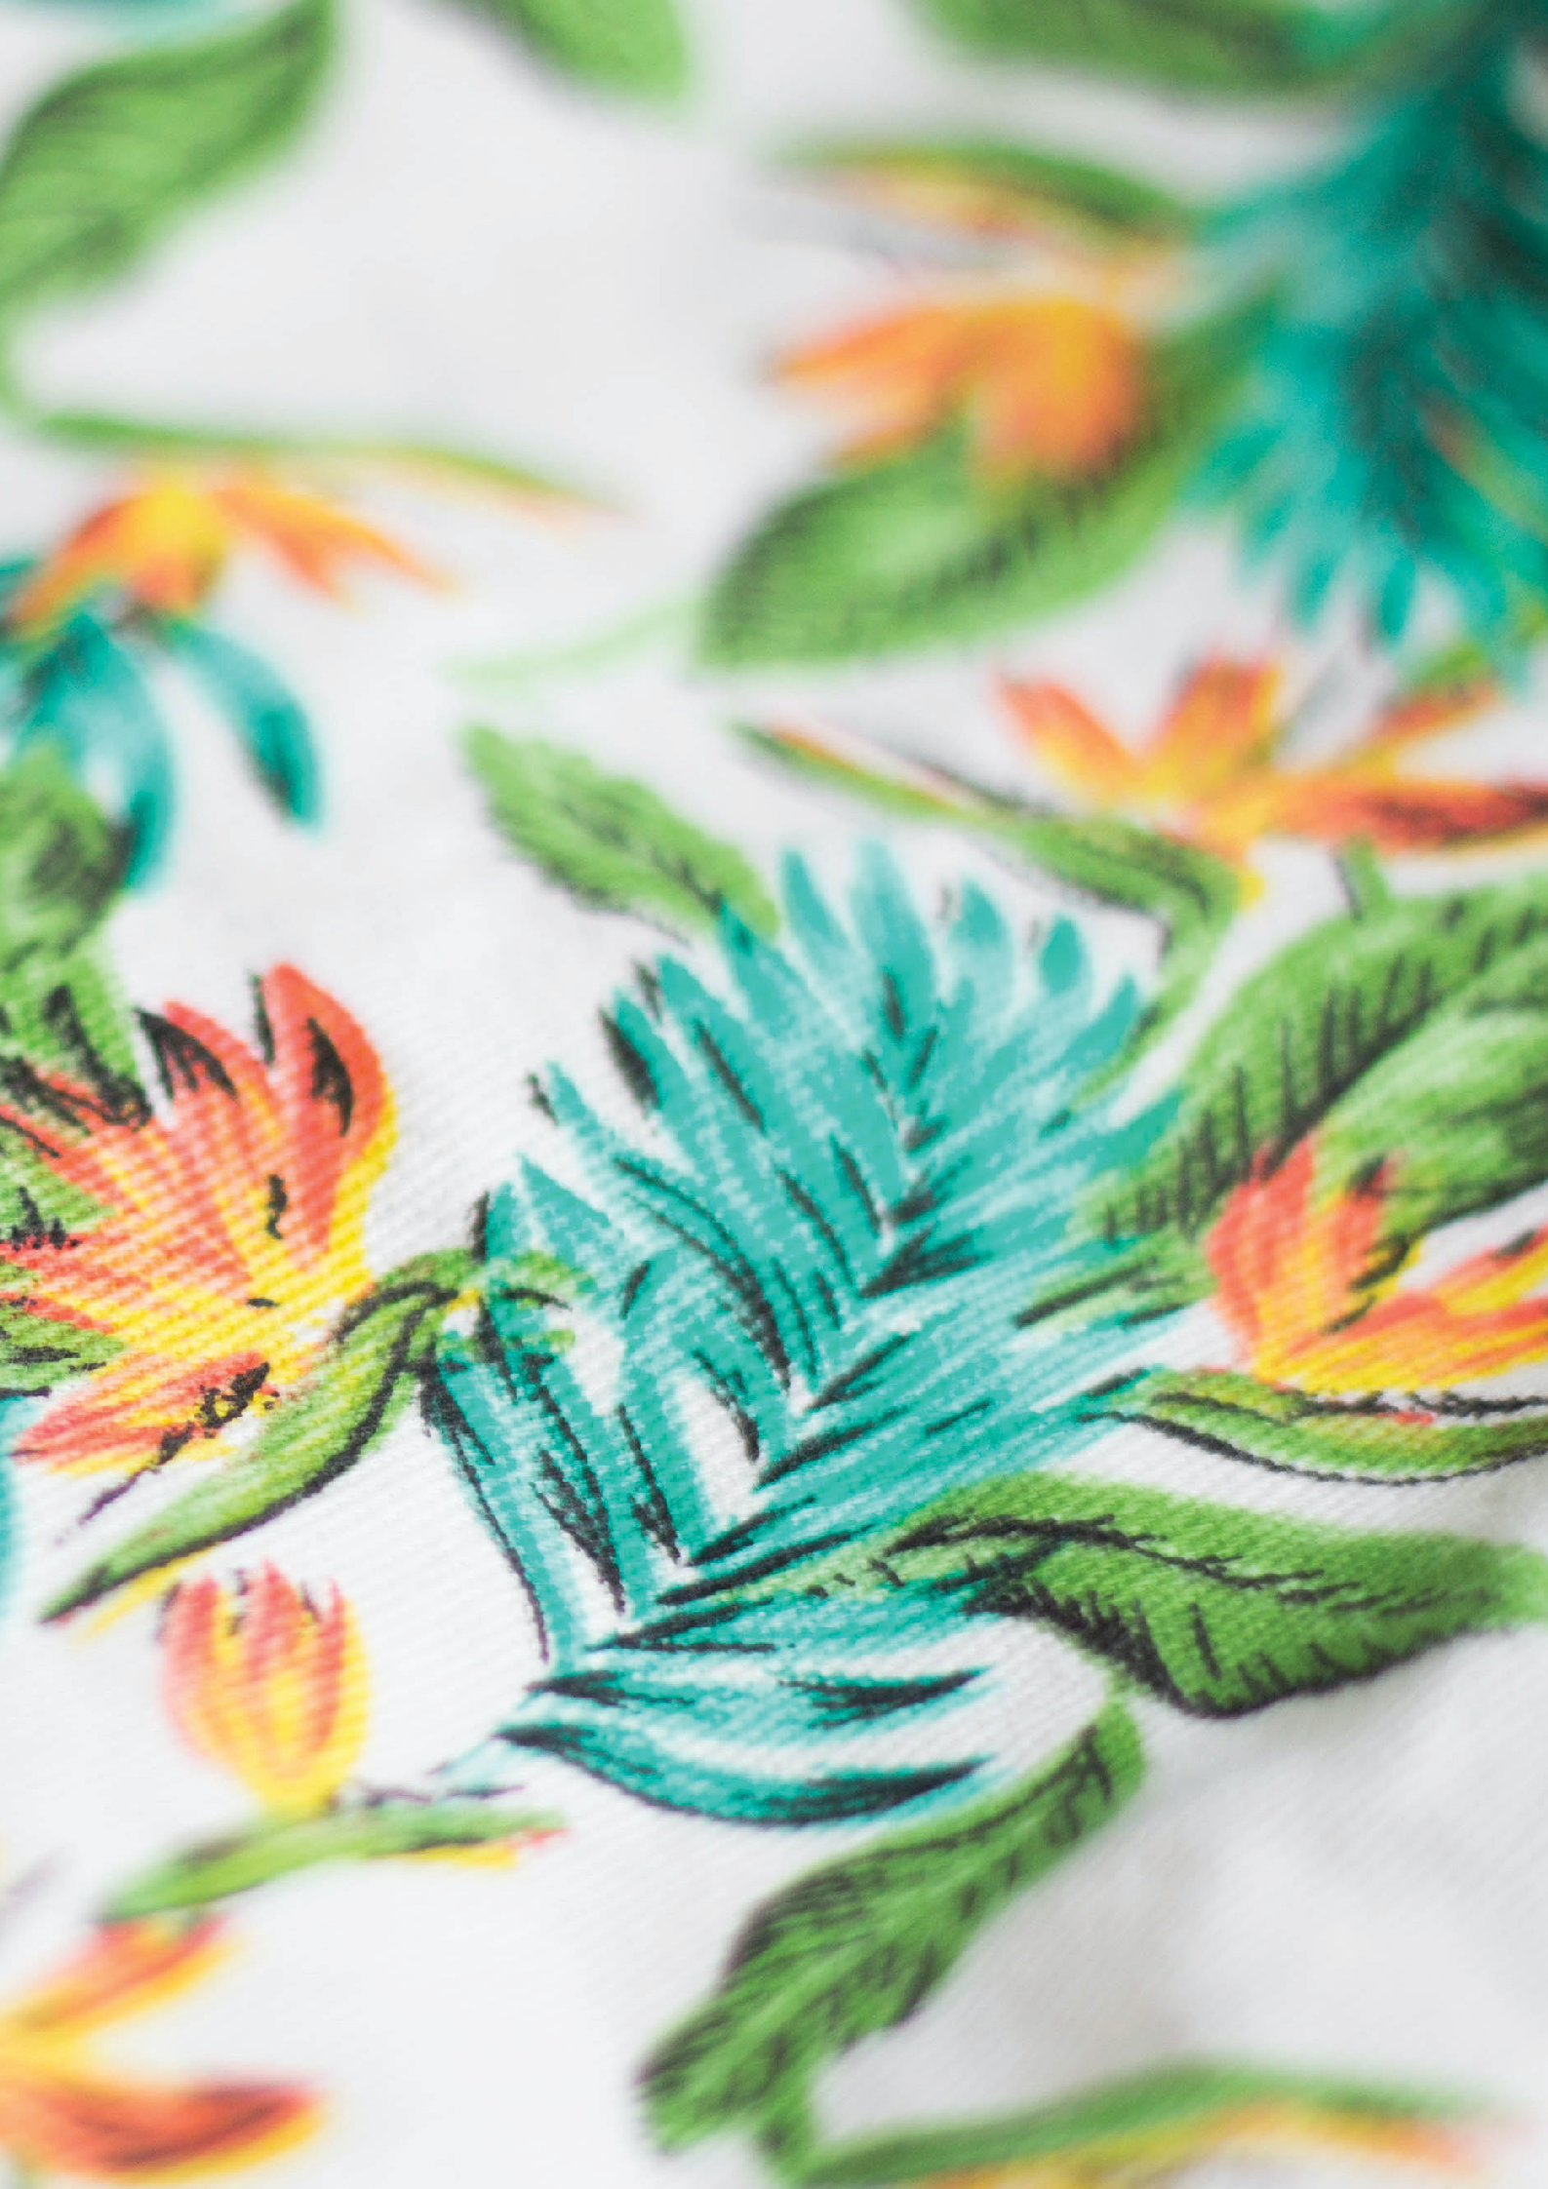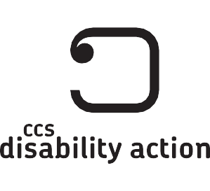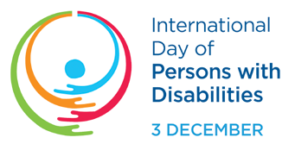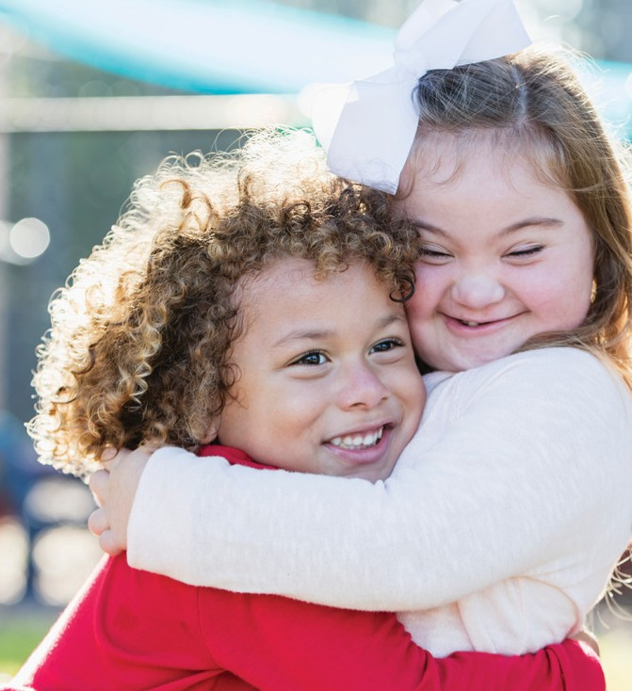

Get in touch Whakapā mai

Please contact Sandy for more information about this event.

**Sandy Nuku**

Service Coordinator 06 278 7121

[SouthCentralTaranaki@ccsDisabilityAction.org.nz](mailto:SouthCentralTaranaki@ccsDisabilityAction.org.nz)

[www.facebook.com/ccsDisabilityAction](http://www.facebook.com/ccsDisabilityAction) @ccsdisabilityaction [www.ccsDisabilityAction.org.nz](http://www.ccsDisabilityAction.org.nz/)