Celebrate International Day of Persons with Disabilities

at our open day

Learn about our organisation, connect with community members, and try out new skills in our Royal Oak community garden.

Refreshments and NZSL interpreters will be provided.

# Details

**When:** Tuesday 5 December 2023 10am to 1pm

**Where:** CCS Disability Action

Dig It Garden 14 Erson Ave Royal Oak

**RSVP:** Please RSVP for catering purposes

We look forward to celebrating with you.

International Day of People with Disabilities (IDPwD) celebrates the achievements and contributions of disabled people to our community. It aims to build awareness, understanding and acceptance.

This event is proudly celebrating:

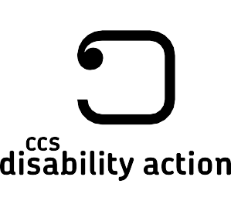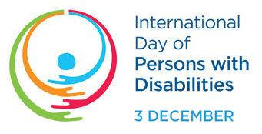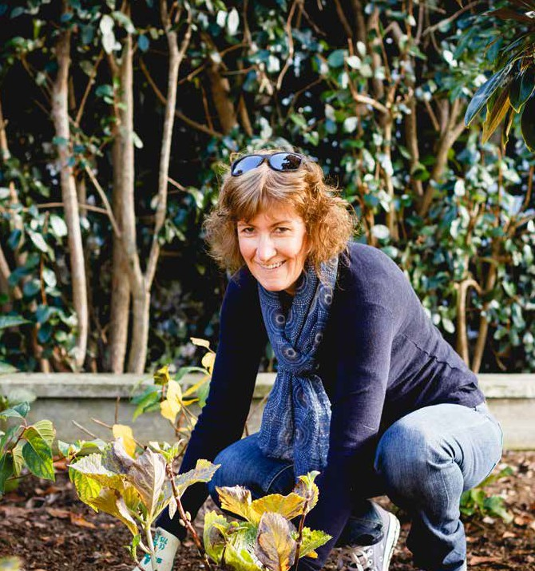

Get in touch Whakapā mai

Please contact Kylie for more information about this event.

**Kylie Elsbury-Dawson**

Service Coordinator 027 695 0320

[Kylie.Elsbury-Dawson@ccsDisabilityAction.org.nz](mailto:Kylie.Elsbury-Dawson@ccsDisabilityAction.org.nz)

[www.facebook.com/ccsDisabilityAction](http://www.facebook.com/ccsDisabilityAction) @ccsdisabilityaction [www.ccsDisabilityAction.org.nz](http://www.ccsDisabilityAction.org.nz/)